EASTERN PROVINCE
KAYONZA DISTRICT
P 1 ENGLISH END OF TERM TWO EXAMINATION 2022-2023.
NAME:____________________________________________
SCHOOL: _________________________________________
1. Match those words. 5marks
Blue ackbl
Yellow reeng
Black nkip
Green llowye
Pink lueb
2. Draw the following objects 5 marks
Apen | A box | A chair | A cup | A book

3. Choose the appropriate answer. 6 marks
- We us _a pencil to draw.
- Teacher use a chalk to write.
- You are in p1
4. Answer these questions. 8 marks
I .what is your name
My name is Ange
2. How are you?
I am fine
3. How old are you, am 6 years
4. Match
One 9
Four 5
Five 1
Ten 4
Nine 10

6.Use Yes, it is or No, it is not. 3 marks
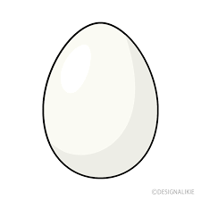Is this an egg? YES

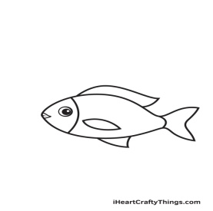Is this a cow? NO
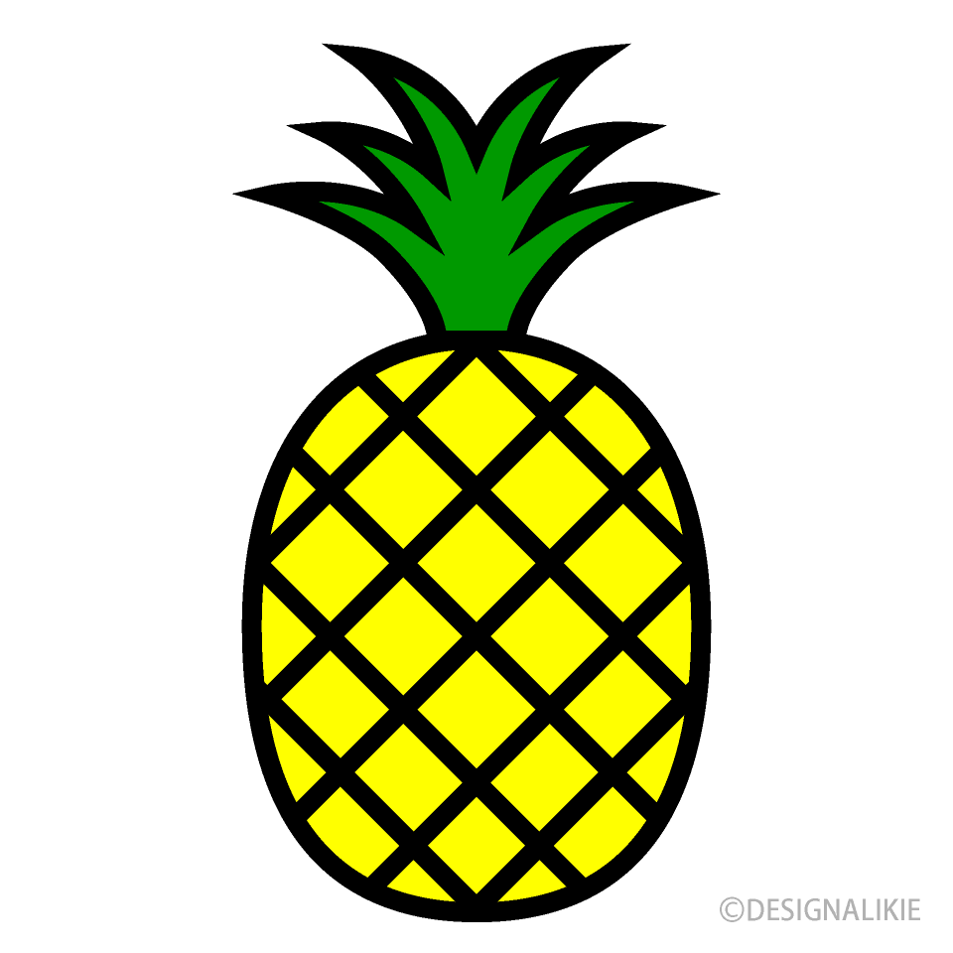Is this a pineapple? YES
7. Circle to the class room objects 8 marks
- A Chalk
2. A stone
3.A car
4. a pen
5. Blackboard
6. Tree
7. Note book
8. Use under ,in and on 3 marks
The star is on the table

The cup is under the chair

Water is in The cup

9. Use dislikes OR like 5marks
a. My mother dislikes people with bad behaviors
b. Our teacher like us very much
c. I like mangoes more than pineapple
d. Do you like story?
e. I like my father so much
10. Fill in the missing letters 2 marks
a. Ball
b. Bag

