KAYONZA DISTRICT
MARKING GUIDE FOR PRIMARY ONE
SOCIAL AND RELIGIOUS STUDIES (2O22-2O23)

- Social studiesare the study of man and his surroundings. (Science, Social study)
- A homeis a place where people live
- Give any 2 examples of home materials you know. 2mrks
CUP.
BED
- Read and match family members with their role at home.3marks

Father Cooks food at home.

Mother Help parents.

Children Heads a family.

- Circle on the name of Rwanda national anthem. 2mrks

Yes we can.
Oh Uganda.
Rwanda nziza.
- Name two colours of Rwanda national flag.6mrks
BLUE.
YELLOW.
GREEN.
- Read and match the following materials used to clean our bodies with their names.6mrks
 Soap

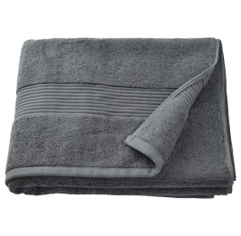

Towel
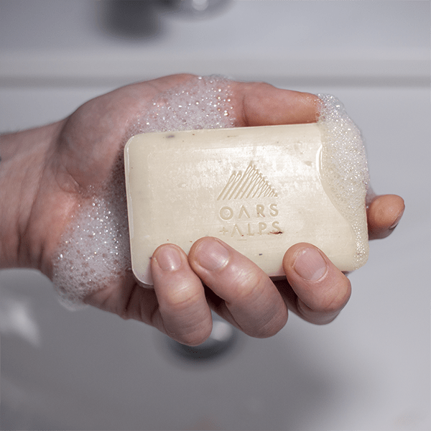 Tooth brush

- Read and draw the following school item below.8mrks

Book | Pencil | Rubber | chalk

- Give two (2) things you see when coming to school.2marks
Trees.
Cars.
Hills.
- Read and match the following below: 3mrks

Red. Go.

Yellow. Stop.

Green. Get ready.

- God.is the father of Jesus. ( Satan, God)2mrks
- Give two animal which live in water that God created.2mrks
Fish.
Frog.
Crocodile.
- I clean my body using soap and water
(Stones, soap, pen, water)2marks

- Draw the following bad things we see when coming to school.8mrks
Dog | Snake. | Bee. | Thorns

- Read and match the following symbols below.8mrks
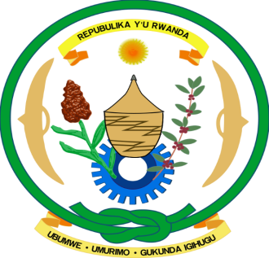 School uniform.
 National coat of arm.

 National flag

- Read and match the following building materials.10marks
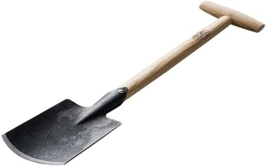 Iron sheet.
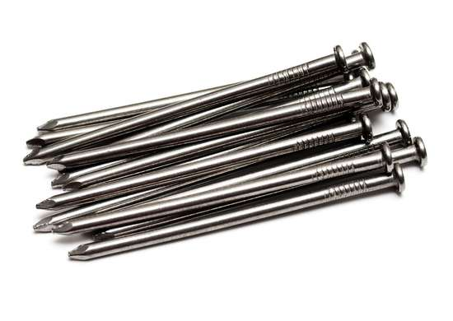Bricks.
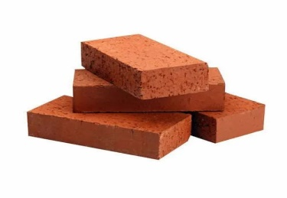 Spade.
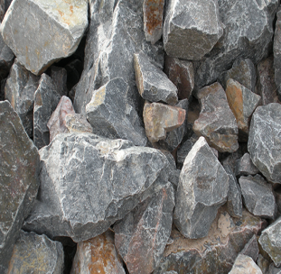Stones.
Nails.

- Name the following parts of a house below:4marks

Roof
Wall
Window

…… Door
(Window, Door,wall , Roof)

!!!!!!!!!!!!!!!!!!!!!!!!!!!!!!!!!!!!!!!!!GOOD LUCK!!!!!!!!!!!!!!!!!!!!!!!!!!!!!!!!!!!!!!!!!!!!!!!!!

