KAYONZA DISTRICT
END OF TERM TWO EXAMINATIONFOR PRIMARY ONE
SOCIAL AND RELIGIOUS STUDIES (2O22-2O23)
Name:………………………………………………………………………………………date………………………..
Class:……………………………………………………………………..stream………………………………………
INSTRUCTIONS:
DURATION: 2hours
- ANSWER ALL QUESTIONS.
- USE ONLY PENCIL TO ANSWER.

- …………………………………………are the study of man and his surroundings. (Science, Social study)2marks
- A …………………………..is a place where people live.(forest, home)2mrks
- Give any 2 examples of home materials you know. 2mrks
………………………………………………………………………………………………………………………………………………………………………………………………………………………………………………………………
- Read and match family members with their role at home.3marks

Father Cooks food at home.

Mother Help parents.

Children Heads a family.

- Circle on the name of Rwanda national anthem. 2mrks
Yes we can.
Oh Uganda.
Rwanda nziza.
- Name two colours of Rwanda national flag.6mrks
………………………………………………………………………………………………………………………………………………………………………………………………………………………………………………………………………………………………………………………………………………………………………………………………
.
- Read and match the following materials used to clean our bodies with their names.6mrks
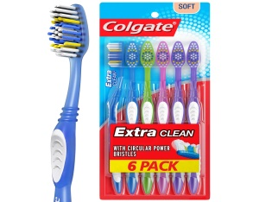 Soap

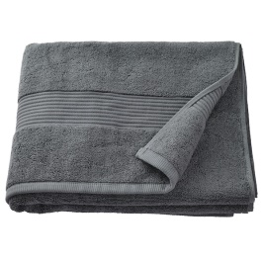

Towel
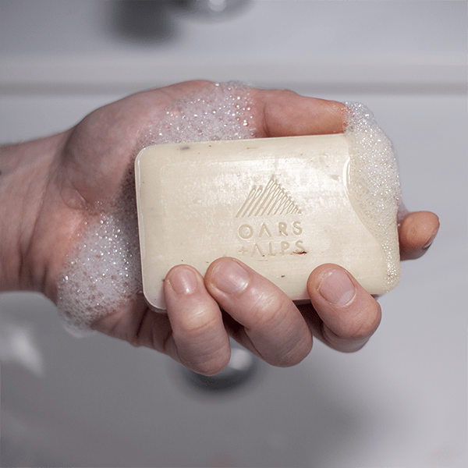 Tooth brush.

- Read and draw the following school item below.8mrks

Book | Pencil | Rubber | chalk

9.Give two (2) things you see when coming to school.2marks
………………………………………………………………………………………………………………………………………………………………………………………………………………………………………………………………………………………………………………
10.Read and match the following traffic lights and their meaning: 3mrks

Red. Go.

Yellow. Stop.

Green. Get ready.

11.……………………….is the father of Jesus. ( Satan, God)2mrks
- Give two animal which live in water that God created.2mrks
……………………………………………………………………………………………………………………………………………………………………………………………………………………………………………………………….
- I clean my body using …………………………and…………………………..(Stones, soap, pen, water)2marks

- Draw the following bad things we see when coming to school.8mrks
Dog | Snake. | Bee. | Thorns

- Read and match the following symbols below.8mrks
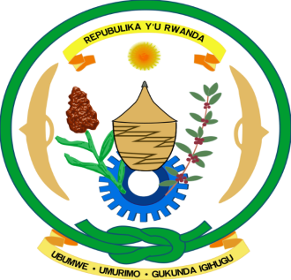 School uniform.
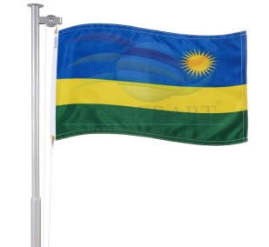 National coat of arm.

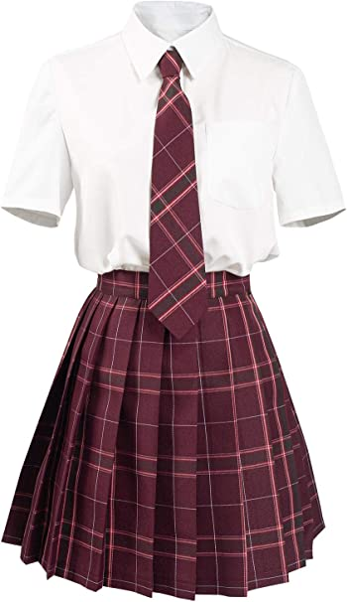 National flag

- Read and match the following building materials.10marks
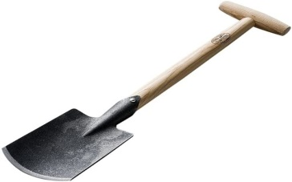 Iron sheet.
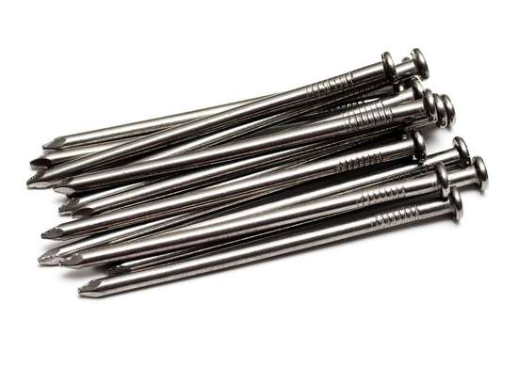 Bricks.
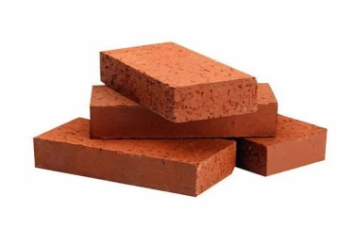 Spade.
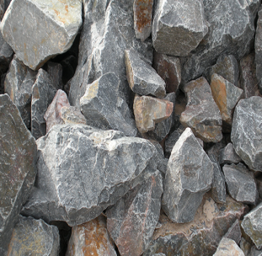 Stones.
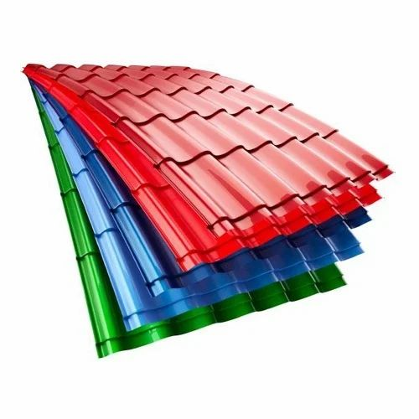

Nails.

- Name the following parts of a house below:4marks

…………………………

………………………..
…………………….
………………………
(Window, Door, wall, Roof)

!!!!!!!!!!!!!!!!!!!!!!!!!!!!!!!!!!!!!!!!!GOOD LUCK!!!!!!!!!!!!!!!!!!!!!!!!!!!!!!!!!!!!!!!!!!!!!!!!!

