KAYONZA DISTRICT
END OF TERM TWO MARING GUIDE FOR PRIMARY TWO
SCOCIAL AND RELIGIOUS STUDIES (2022-2023)
- Social studies is the study of man his surroundings.1mrks
- Give any 3 examples of things surrounding our village.3mrks
Hill.
Trees.
Flowers.
Animals.
- Circle on diseases caused by poor hygiene.
- Cholera
- Aids.
- Typhoid.
- Marasmus.
- Worms.
4. Use the given diseases and fill in the table below: 8marks
- Jiggers. -Kwashiorkor.
-Typhoid. -Diarrhea.
-Marasmus. -Rickets.
Diseases caused by poor hygiene | Diseases caused by poor feeding
Typhoid. | Marasmus.
Diarrhea. | Kwashiorkor.
Jiggers. | Rickets.

5. Put the following in their group. 6marks
- Telephone.
- A market. - Tito’s house.
- A road. - School.
- Computer.
Personal assets | Public assets
Telephone  Computer.  Tito’s house | A market.  A road.  A school.

- Give three colours of Rwanda national flag.3marks
Blue.
Yellow.
Green.
7. Complete the following with (school, village, cell, and home)
- Home is a place where people live.
- Village is a place made up of several home steads.
- School is a place where we go to study.
- Cell is a place made up of many villages.
8. Nuclear family is a family made up of father, mother and their children. (Extended family, Nuclear family) 2marks
9. Fill in the table using the given work below: 4marks
-Studying well.
-Helping parents.
-Respecting teachers.
-Cleaning your bed room.
Responsibilities/work at school | Responsibilities/work at home
Studying well.  Respecting teachers | Cleaning your bed room.  Helping parents.

10. Read and match the following building materials below:12marks
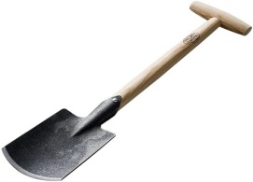 Stones.
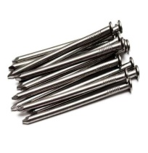 Bricks.
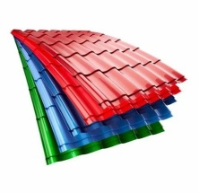 Spade.
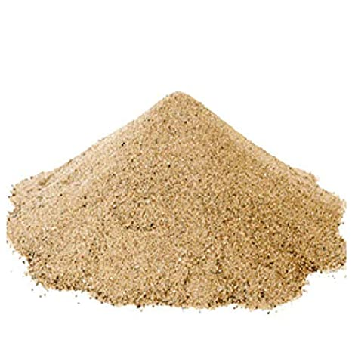 Nails.
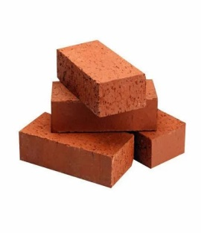 Iron sheet
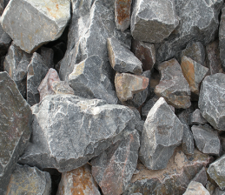 Sand.

11. Put the following words in their order according to basic needs and non- basic needs in the table below: 8marks
- Food. –Computer.
- Car. –Medicine.
- House. –Watch.
- Television.
- Clothes.
Basic needs | Non-basic needs
Food.  House.  Clothes.  Medicine. | Computer.  Car.  Television.  Watch.

12. Give two sons of Adam and Eve.2marks
Cain.
Abel.
13. Give two members of an extended family.2marks
Uncle.
Aunt.
14. Name any two places of worship found in our cell.2marks
Church.
Mosque.
15. Environment is all things around us. 2marks
16. State at least two things around your village.2marks
Sun.
Hills.
Rivers.
Swamps.
17. Mention any two examples of school properties.2marks
Chalk.
Desks.
Text book.
18. Complete the table by using the given words below:6 marks
- Fish.
- Cassava.
- Mango.
- Orange.
- Meat.
- Maize.
Body building food | Body protecting food | Energy giving food
Fish. | Mango. | Cassava.
Meat. | Orange. | Maize.

19. Circle things that protect environment in our cell.2marks
- Planting trees.
- Bush burning.
- Cutting down trees.
- Cleaning trenches.

20. Read and match the following carefully.

Head teacher. Heads a cell.

Village chief. Heads a school

Executive of cell. Heads a village.

!!!!!!!!!!!!!!!!!!!!!!!!!!!!!! SUCCESS TO YOU ALL!!!!!!!!!!!!!!!!!!!!!
ALWAYS LOVE YOUR NEIGHBOUR AS YOU LOVE YOURSELF

