
SCIENCE AND ELEMENTARY TECHNOLOGY
PSET

DURATION: 2 HOURS

KAYONZA DISTRICT
Pupil’s names
Surname: ……………………………….……………………………………………………………….…
Other names: ………………………..………….……………………………….…………………………

MARKS:
/70
END OF TERM TWO DISTRICT EXAM FOR PRIMARY FOUR, 2023

READ THESE INSTRUCTIONS CAREFULLY:
- A prayer is always vital before the start.
- Do not open this paper until you are told to do so.
- Before starting, verify if all pages and all questions are there and are arranged in order.
- Attempt ALL questions.
- Read each question carefully before answering it.
- Answer the questions in the space provided in this question paper.
- You must use only a BLUE PEN.
- Poor handwriting that cannot easily be read and unnecessary crossing of answers will lead you to loss of marks.

I. Moving air over land is called?
…………………………………………………………………………..
2. Name one characteristic of living things.
………………………………………………………………………….
3. Give one use of domestic animals at home.
…………………………………………………………………………….
4. The washing away of top soil from one place to another is called
…………………………………………………………………………
5. Give one use of plants to man.
………………………………………………………………………………………
6. Give one use of rain water at home.
…………………………………………………………………….
7. What do you understand by the term “pitch of sound”?
…………………………………………………………………………….
8. Name two components of soil.
i)……………………………………………………………………………
ii)………………………………………………………………………….
9. Name the gas necessary for rusting to take place.
……………………………………………………………………………..
10. Name the part of air used in preservation of bottled drinks such as soda and beer.
…………………………………………………………………………

Choose and circle the best alternative
11. The best soil for crop growing is called?
a. Loam soil b. Clay soil
c. Drained soil d. Sand soil
12. Loam soil is the best soil for crop growing because:
a. It is well drained b. It has air
c. It has humus d. It has rock particles
13. The type of soil that has very small particles close to each other is called?
a. Clay soil b. Aerated soil
c. Loam soil d. Sand soil
14. Which of the following gases has the highest percentage composition in air?
a. Oxygen b. Carbon dioxide
c. Nitrogen d. Neon
15. Which gas supports burning?
a. Hydrogen b. Oxygen
c. Carbon dioxide d. Rare gases
16. Which gas is used in a fire extinguisher?
a. Oxygen b. Carbon dioxide c. Helium d. Argon
17. The main source of energy on earth is the
a. Sun b. Moon c. Gas d. Fire wood
18. Name the green coloring matter found in leaves
a. Node b. Inter node c. Chlorophyll d. Venation
19. Tools used by a farmer are known as.
a. Carpentry tools b. Blacksmiths’ tools
c. Agricultural tools d. Masonry tools
20. The following are conditions for photosynthesis to take place except one.
a. water b. sun light
c. carbon dioxide d. oxygen
21. The diagram below shows the arrangement of soil layers.( top soil , parent rocks , subsoil , gravel )
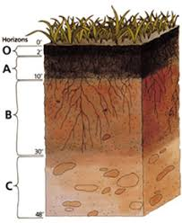
22 .The mixture of gases is called
………………………………………………………………………
23. Match the gases in air with their percentage composition
A B
Carbon dioxide 78%
Oxygen 0.97%
Nitrogen 0.03%
Rare gases 21%
24. a) What is soil? ……………………………………………………………
………………………………………………………………………………………
b) Name the three types of soil
i)…………………………………………………………..
ii)………………………………………………………..
iii)…………………………………………………………
25.a) Give two properties of air
i)…………………………………………………………..
ii)……………………………………………………………
b) Which property of air is shown below.
…………………………………………………..
26. Write true or false
a) Plants are non living things
……………………………………………………………………………….
b)Soil is the top most layer of the earth surface.
………………………………………………………………………………
c) Wind is moving air.
……………………………………………………………………………….
d) Air has no weight.
…………………………………………………………………………………..
27a) What is sound? …………………………………………………………………………………….
b. Study the diagrams below and answer questions that follow.
A B
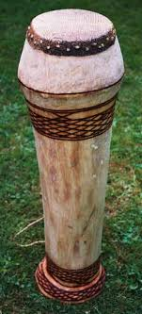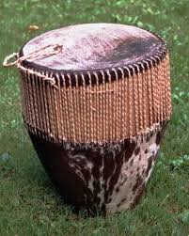
i) Which drum produces the highest pitch of sound?
……………………………………………………………………….
ii) Which drum produces the lowest pitch of sound?
………………………………………………………………………………
28. Name the garden tools below and their uses.
TOOL | NAME | USE
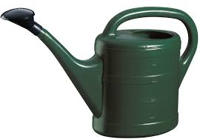
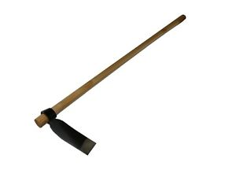
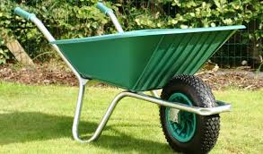
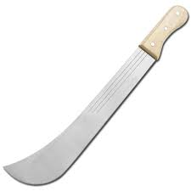
29. Give the four sub groups of vertebrate animals.
i)……………………………..………ii)………………………………………… iii)………………………………………iv)………………………………………….
30.Write HTML in full……………………………………………………………………………………….
31. List two types of booting
i)……………………………………………. ii)……………………………………..
32.Give two uses of computers.
i)…………………………………………………………………………………..
ii)……………………………………………………………………………………
33.Name two interfaces found in the XO Laptop computer.
i)………………………………………………………………..ii)……………………………………………………..
34. In which ways can you start using the write activity?
i)…………………………………………………………………………………..
ii)……………………………………………………………………………………
iii)…………………………………………………………………………………..
35.Any four screen views you can interact with, in Sugar interface are
i) ………………………………………………………………………………
ii)………………………………...........…………………………………………
iii) ………………………………………………………………………………
iv)………………………………...........…………………………………………
**End**

