
SCIENCE AND ELEMENTARY TECHNOLOGY
PSET

DURATION: 2 HOURS

KAYONZA DISTRICT
Pupil’s complete index number
Province District Sector School Pupil Year

Pupil’s names
Surname: ……………………………….……………………………………………………………….…
Other names: ………………………..………….……………………………….…………………………………………………….

MARKS:
/100
END OF TERM TWO DISTRICT EXAM FOR PRIMARY SIX, 2023

READ THESE INSTRUCTIONS CAREFULLY:
- A prayer is always vital before the start.
- Do not open this paper until you are told to do so.
- Before starting, verify if all pages and all questions are there and are arranged in order.
- Attempt ALL questions.
- Read each question carefully before answering it.
- Answer the questions in the space provided in this question paper.
- You must use only a BLUE PEN.
- Poor handwriting that cannot easily be read and unnecessary crossing of answers will lead you to loss of marks.
- Burning bushes and forests in not allowed and is punishable because it releases carbon dioxide and carbon monoxide gases into the atmosphere. State any two dangers that these gases can cause when released into the atmosphere. /2
i)___________________________________________________________________________________________________________________________________
ii)___________________________________________________________________________________________________________________________________
2.Explain why it is not good to cook with charcoal or firewood in a locked room? /1
____________________________________________________________________________________________________________________________________________
3.Explain why the government of Rwanda stops people from smoking in public places? /1
_____________________________________________________________________
_____________________________________________________________________
4.Air pollution refers to the addition of harmful substances into air. Besides carbon dioxide, mention any other two pollutants that are gaseous in nature. /2
i)____________________________________________________________________
ii)____________________________________________________________________
5. Identify any two human activities that cause air pollution. /2
i)____________________________________________________________________
ii)____________________________________________________________________
6.What special name is given to:
a) the increase in the temperatures of the earth caused by the increase of carbon dioxide in the atmosphere? /1

______________________________________________________________________
b) the condition of being deprived of oxygen? /1
______________________________________________________________________
7. Complete the cross word puzzle with the clues below. /5
Across
3. The connectivity between XO laptops.
4. Instructions that tell a computer what to do and when to do it.
5. An input device of a computer that is used to type data.
Down
1. The keys available on a multimedia keyboard.
2.A device for controlling the cursor on a screen by sliding the finger along a touch sensitive surface.

 |  |  |  |  |  |  | 1 |  |  |  | 2
3
4
 |  |  |  |  |  | 5

8.Modern technology has made it possible to store sound. Mention any two devices that can be used to store sound.
i)___________________________________________________________________
ii)___________________________________________________________________
9. Complete the following sentences using the words given below.
Communication, Information, project, Icon, internet, Application, website
/7
- ______________________is a program which allows you to perform a particular task in a computer.
- ______________________ is the small picture that represents a folder or program in a computer.
- __________________________is processed data.
- ________________________ is a planned set of interrelated task.
- ________________________ is the sending and receiving of information.
- _______________________ is a group of pages belonging to an organisation about a topic or application.
- ____________________________ is a large group of computers connected to each other .

10.Complete the following sentences using the words given below.
Sugar interface, window, sugar input system, Gnome interface, paint activity, write activity,
/6
a). ______________________________ are devices which allow a computer user to enter information in the computer.
b). ______________________________ is a system software designed for children to learn on.
c) ________________________________ is a graphic user interface with many applications designed to help children in their work.
d). _______________________________is the activity that provides one with tools which help someone to write a word, sentence or story in the computer.
e). ____________________________ is an area occupied by running programs in a computer.
f). ______________________________ is how to frame up art work by matching tones and colours to produce beautiful work.
11. A knife was left outside overnight. On checking it the following morning, it had developed a brownish colour .
a)What special name is given to the brownish colour that formed on the knife? /1
________________________________________________________________
b)Write down any two things that can be done in order to prevent metals from developing the brownish colour. /2
i)____________________________________________________________________
ii)____________________________________________________________________
- a) Identify and give the use of each of the tools shown in the pictures below, as used by blacksmiths.(6marks)
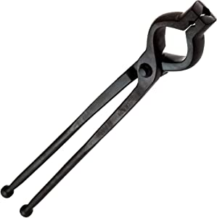

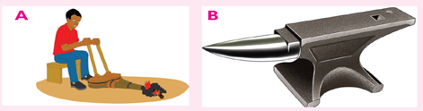
C
Tool | Name | Use
A

B

C

b) What does a mechanic do? /1
…………………………………………………………………………………………
13. Identify the following simple machine. ( 5marks)

(a) I am a lever. I am used to catch fish from a waterbody. Who am I? …………………………………………………………………………………….
(b) I have a string on a wheel. I help pull loads up and down. Who am I? ……………………………………………………………………………………..
(c) I help you get from the first floor to the third floor. I have steps. Who am I? …………………………………………………………………………
(d) I hold together pieces of wood. I have a spiral part. Who am I? ………………………………………………………………………..
(e) I have sharp cutting edges. I help you to split firewood. Who am I? ………………………………. ………………………………………

14.Toys are things children play with. These things can be made by the help of local materials from our environment. Which materials can we use to make toys? /3
i)……………………………………………………………………………….
ii) ………………………………………………………………………………
iii) ……………………………………………………………………………
15.Basketry refers to the art of making baskets. From which materials can baskets be made? 2
i) ……………………………………………………………………
ii) ……………………………………………………………………………….
16. Given the animals below.
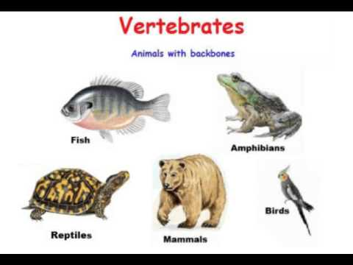
R
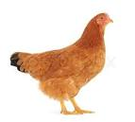

Z

Q
P
N
M
- To which group of animal kingdom do all the animals above belong? 1mark
……………………………………………………………………………….
- To which group of vertebrate animals does each of the animals above belong? 5 marks.
- N……………………………………………………………………………….
- P……………………………………………………………………………
- Q…………………………………………………………………………
- M ……………………………………………………………………………
- R……………………………………………………………………………….
- State one similarity between the animals ; i) Q and M……………………………………………………………………………
………………………………………………………………………(1mark)
ii) N and R……………………………………………………………………………
………………………………………………………………………………(1 mark)
- State one difference between the animals ; i) Q and M……………………………………………………………………………
………………………………………………………………….(2 marks)
ii) N and R……………………………………………………………………………
……………………………………………………………………………….(2 marks)
- How does animal R reproduce? 1mark
…………………………………………………………………………………….
17. Locomotion refers to the movement of animals from one place to another. Why do animals move from one place to another? (4 marks)
i)……………………………………………………………………………………….
ii)………………………………………………………………………………………
iii)………………………………………………………………………………………
iv)……………………………………………………………………………………..

18. Mammals feed their young ones on breastmilk and produce young ones alive. Put down two animals that belong to this group. /2
i)………………………………………………………………………………………..
ii)……………………………………………………………………………………….
19. What do you understand by the term ‘vertebrates’? /1
……………………………………………………………………………………………………………………………………………………………………………………………………………………………………………………………………………………
20.Explain the following terms.
- Photosynthesis
………………………………………………………………………………………………………………………………………………………… /1
ii)Pollination……………………………………………………………………………………………………………………………………………………………… /1

21.Complete the table below by putting a tick (√) the appropriate method of propagation. ( One was done for you) /6

Plant |  | Method of propagation
 | Seeds | suckers | Grafting | Stem cutting | Bulbs | Stem tubers
Soya beans | √
Cassava
Euphobia
Banana plant
Pineapples
Maize
Elephant grass.

22. The diagram below shows part of a flower. Name the labelled parts.
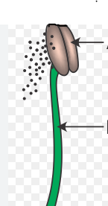 / 2 marks.
23. a) A special machine that allows eggs to hatch is called
_________________________________________________/1mark
bWrite down two types of brooding. /2
i)______________________________ ii)______________________
c. Hens produce by ………………………………………………………………………………………/1
d. Give two importance of chicken farming. /2
i………………………………………………………………………………………………………………………………………………………………
ii………………………………………………………………………………………………………………………………………………………………
24. A male rabbit is called a …………………………………………………….. while a female rabbit is called a ……………………………………………/2
b. How do we call a house of rabbits? /1
…………………………………………………………………
c. Which disease affects both rabbits and chickens? /1mk

…………………………………………………………………………………
- a) What is a simple machine? /1
_________________________________________________________
b. Give any three types of simple machines. /3
i)________________________________________________________
ii)_______________________________________________________
iii)_____________________________________________________
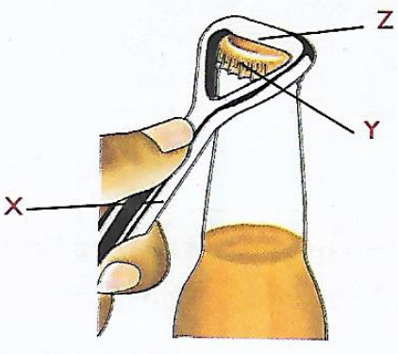
c). The diagram below shows a lever.

(i). Name the parts marked X,Y and Z /3
X: ……………………………………………………….………..
Y: ……………………………………………………….………….
Z: …………………………………………………………………
(ii) To Which class of levers does this tool belong? /1
_________________________________________________________
d) Give any two ways of maintaining simple machines.
i)…………………………………………………………………………………
ii)………………………………………………………………………………….
**End**

